### 

### Semester Two Examination, 2019

### Question/Answer booklet

### MATHEMATICS METHODS

**UNIT 1 AND 2**

## Section One:

## Calculator-free

Name: _______________________________________________________

Teacher’s Name: _______________________________________________

## Time allowed for this section

## Reading time before commencing work: five minutes

## Working time: fifty minutes

## Materials required/recommended for this section

## *To be provided by the supervisor*

## This Question/Answer booklet

## Formula sheet

## *To be provided by the candidate*

## Standard items: pens (blue/black preferred), pencils (including coloured), sharpener, correction fluid/tape, eraser, ruler, highlighters

Special items: nil

## Important note to candidates

No other items may be taken into the examination room. It is **your** responsibility to ensure that you do not have any unauthorised material. If you have any unauthorised material with you, hand it to the supervisor **before** reading any further.

|  |  |
| --- | --- |
| **Question** | **Marks** |
| **1** |  |
| **2** |  |
| **3** |  |
| **4** |  |
| **5** |  |
| **6** |  |
| **7** |  |
| **TOTAL** |  |

**Structure of this paper**

|  |  |  |  |  |  |
| --- | --- | --- | --- | --- | --- |
| Section | Number of questions available | Number of questions to be answered | Working time (minutes) | Marks available | Percentage of examination |
| Section One:  Calculator-free | 7 | 7 | 50 | 52 |  |
| Section Two:  Calculator-assumed |  |  | 100 |  |  |
|  |  |  |  | **Total** | 100 |

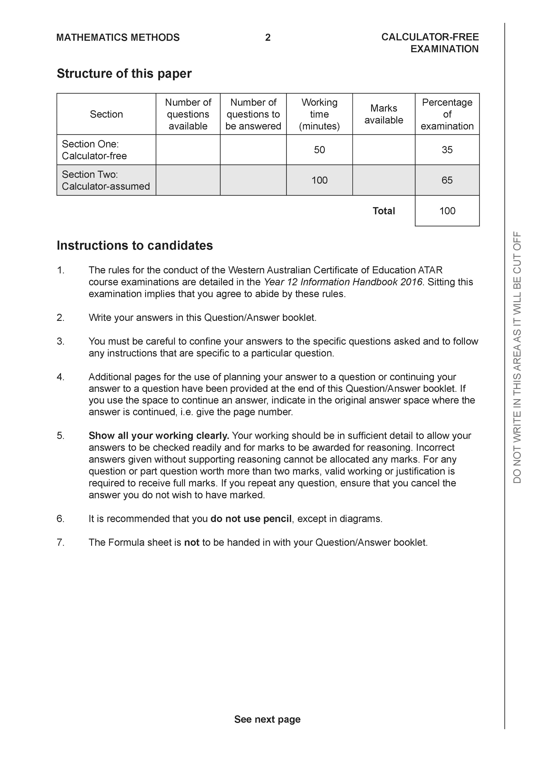

**Section One: Calculator-free (52 Marks)**

This section has **seven (7)** questions. Answer **all** questions. Write your answers in the spaces provided.

Spare pages are included at the end of this booklet. They can be used for planning your responses and/or as additional space if required to continue an answer.

● Planning: If you use the spare pages for planning, indicate this clearly at the top of the page.

● Continuing an answer: If you need to use the space to continue an answer, indicate in the original answer space where the answer is continued, i.e. give the page number. Fill in the number of the question that you are continuing to answer at the top of the page.

Working time: 50 minutes.

**Question 1 (7 marks)**

1. Calculate the value of:
2. (2 marks)

|  |
| --- |
| **Solution** |
| 5 = 10 |
| ✔ Simplifying both terms  ✔ correct answer |

1. (2 marks)

|  |
| --- |
| **Solution** |
| = 0.02 or or |
| ✔ expanded  ✔ correct answer |

1. If , , and are the first three terms of an arithmetic sequence, calculate the value of .

(3 marks)

|  |
| --- |
| **Solution** |
|  |
| ✔ setting up the equation  ✔ correct working  ✔ correct answer |

**Question 2 (10 marks)**

The graph  is shown below.

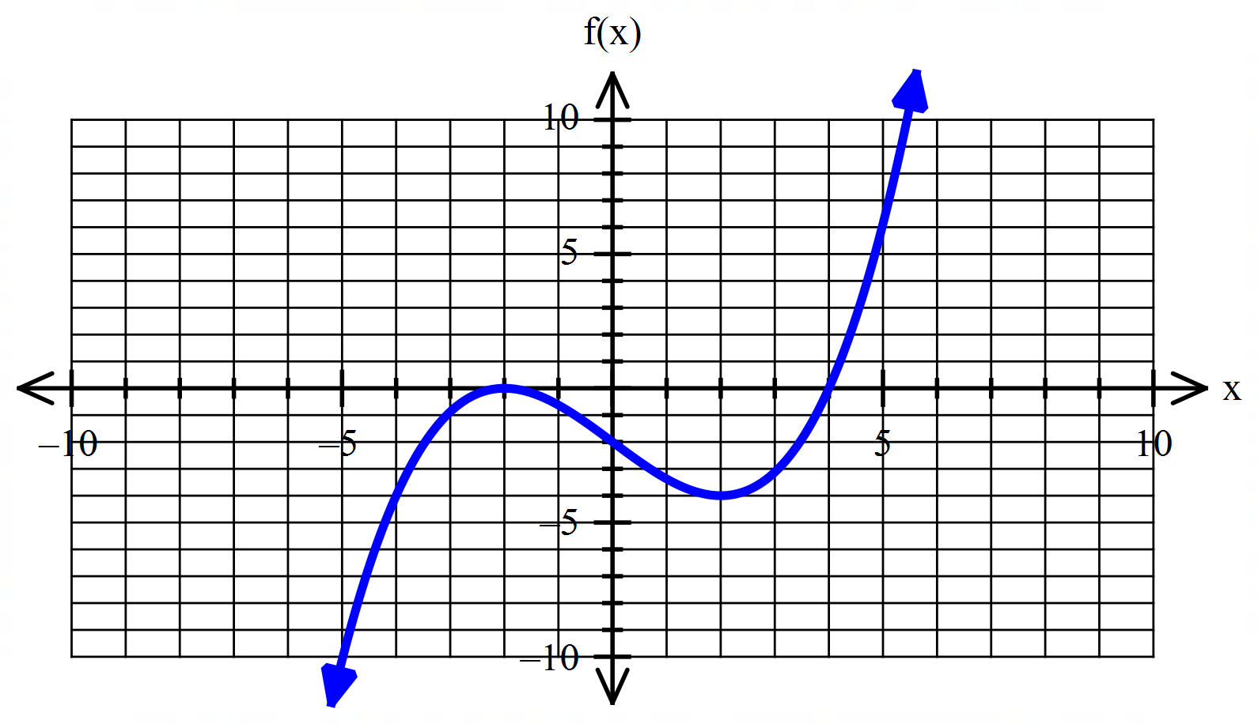

1. Determine the values of the coefficients and . (3 marks)

|  |
| --- |
| **Solution** |
| 2 |
| ✔ finding b  ✔ substituting a point into f(x) correctly  ✔ correct value for a |

1. State the interval(s) where f(x) is decreasing. (2 marks)

|  |
| --- |
| **Solution** |
| OR (-2, 2) |
| ✔ between -2 and 2  ✔ correct inequality signs |

1. The point lies on the function . State the new coordinates under the following transformations.
2. (1 mark)

|  |
| --- |
| **Solution** |
|  |
| ✔ correct coordinate |

1. (2 marks)

|  |
| --- |
| **Solution** |
|  |
| ✔ correct -value  ✔ correct -value |

1. Determine the value(s) for y where there are exactly two solutions to the equation . (2 marks)

|  |
| --- |
| **Solution** |
|  |
| ✔  ✔ |

**Question 3 (5 marks)**

The design for the A380 Qantas sleeping eye mask is illustrated below:

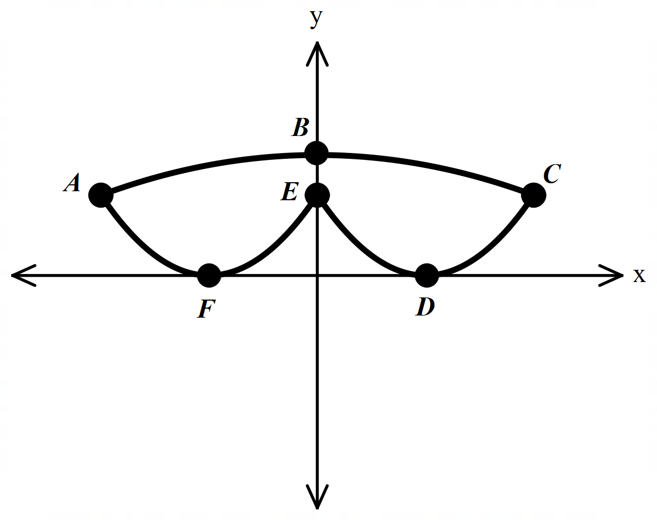

The curves that form the outline are modelled by the equations:

1. Which equation determines the curve ABC? (1 mark)

|  |
| --- |
| **Solution** |
|  |
| ✔ correct equation |

1. Which equation determines the curve AFE? (1 mark)

|  |
| --- |
| **Solution** |
|  |
| ✔ correct equation |

1. If D lies on the axis of symmetry for curve EDC determine its coordinate. (1 mark)

|  |
| --- |
| **Solution** |
|  |
| ✔ correct coordinate |

Given that the units are in centimetres:

1. Find the distance between F and D. (1 mark)

|  |
| --- |
| **Solution** |
| ✔ |

1. Find the distance between E and B. (1 mark)

|  |
| --- |
| **Solution** |
| (curve AFE expanded)  ✔ |

**Question 4 (7 marks)**

If and and both A and B are obtuse angles, find:

1. (2 marks)

|  |
| --- |
| **Solution** |
| Since and are obtuse they lie in quadrant 2. |
| ✔  ✔ negative sign |

1. (2 marks)

|  |
| --- |
| **Solution** |
|  |
| ✔  ✔ negative sign |

1. (3 marks)

|  |
| --- |
| **Solution** |
|  |
| ✔ use the compound formula  ✔ use correct signs for cosines  ✔ evaluate |

**Question 5 (10 marks)**

1. Sketch the graph of on the axes below. (2 marks)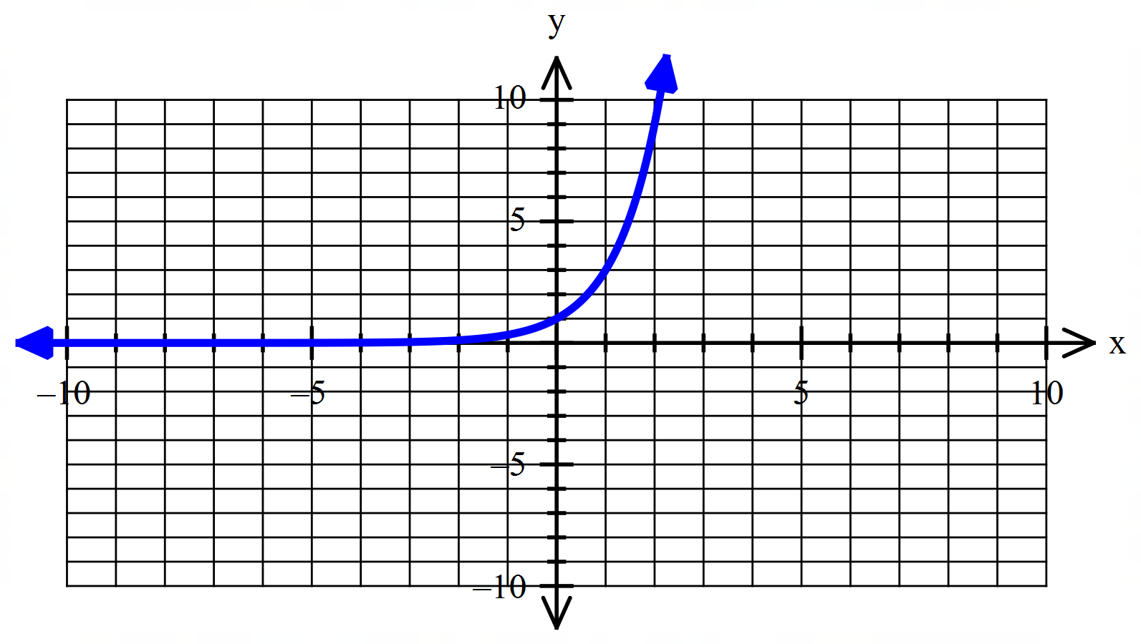

|  |
| --- |
| **Solution** |
| ✔ correct shape with an asymptote at  ✔ must go through and |

1. Describe the transformation that maps
2. the graph of onto the graph of , (2 marks)

|  |
| --- |
| **Solution** |
| ✔ horizontal dilation  ✔ with a scale factor of |

1. the graph of onto the graph of . (1 mark)

|  |
| --- |
| **Solution** |
| ✔ horizontal translation one unit to the left |

1. Show that the equation can be written as . (3 marks)

|  |
| --- |
| **Solution** |
| ✔  Let  ✔  ✔ |
| ✔ Recognising the quadratic equation in terms of .  ✔ substituting  ✔ correct factorising |

1. Solve the exponential equation in part c) giving approximate solution(s) where necessary. (2 marks)

|  |
| --- |
| **Solution** |
| and  and  ✔ and ✔ |
| ✔  ✔ accept a solution between (0.5 – 0.8) (ft as they are reading of their graph in part a)) |

**Question 6 (8 marks)**

1. Simplify

(i) . (1 mark)

|  |
| --- |
| **Solution** |
| ✔ |

(ii) . (1 mark)

|  |
| --- |
| **Solution** |
| ✔ |

(iii) (2 marks)

|  |
| --- |
| **Solution** |
| ✔ (expanding  ✔ (must include +c for the second mark and SIMPLIFIED) |

1. Sketch the graph of a function that satisfies all of the conditions stated below.

(You do **not** need to determine the equation of such a function.) (4 marks)

* The function intercepts the -axis at , and only.
* The function intercepts the -axis at .
* The gradient of the function is zero for and .
* For the gradient is always positive.
* For and the gradient is always negative.

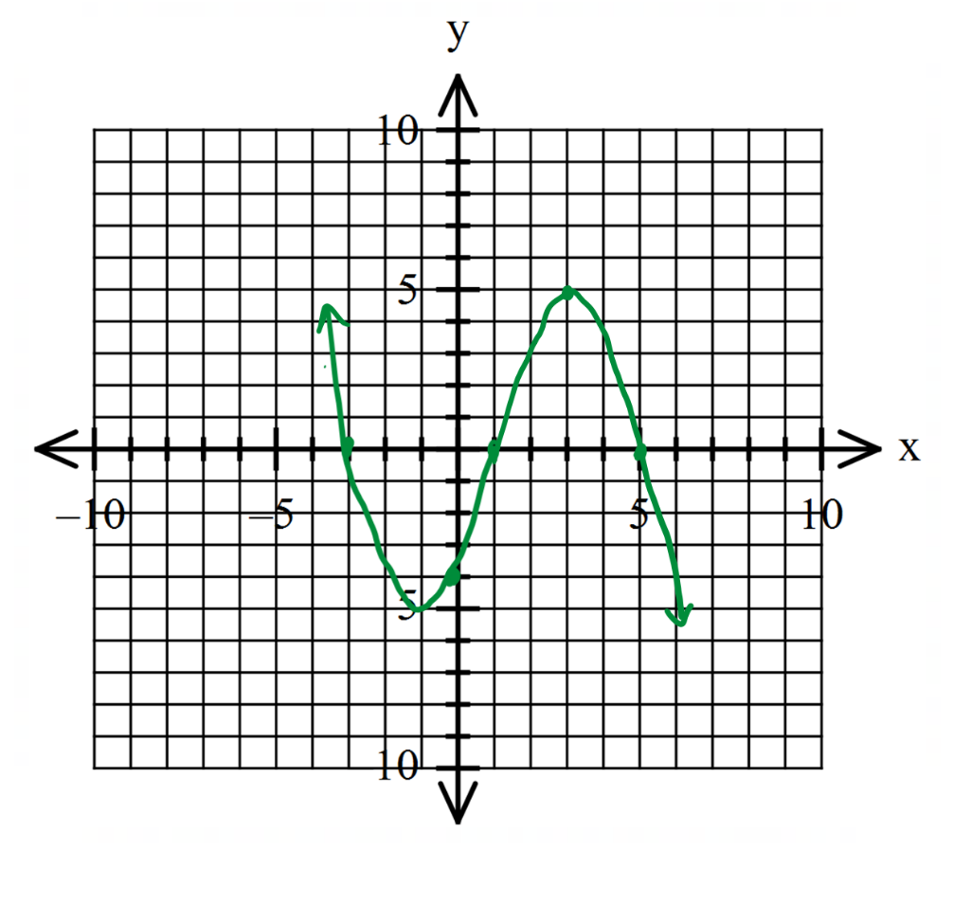

|  |
| --- |
| **Solution** |
| ✔ correct and intercepts  ✔ maximum point at and a minimum point at  ✔ For the gradient is always positive.  ✔ For and the gradient is always negative. |

**Question 7 (5 marks)**

By using a suitable binomial expansion, calculate .

|  |
| --- |
| **Solution** |
| ✔ express as a binomial  ✔ Identifies correct terms and powers and uses correct coefficients  ✔ expands and simplifies  ✔ evaluates fraction out of 32  ✔ correct answer  **\*\*DO NOT ACCEPT . Students must use an appropriate binomial expansion. Award 0 marks if they evaluate .** |

**END OF SECTION**

**Section Two: Calculator-assumed (97 Marks)**

Question 8 (7 marks)

1. Are the straight lines given by  and  parallel, perpendicular or neither? Justify your answer. (2 marks)

|  |
| --- |
| **Solution** |
| Gradient of 3x+4y=12 is -0.75  Gradient of y=0.75x+1.25 is 0.75.  Neither parallel (gradients not equal) nor perpendicular (gradients not negative reciprocals)  Ie m1 ≠m2 and m1 x m2 ≠ -1 |
| ✔ finds gradients  ✔ Compares and states neither |

1. Determine the equation of the straight line perpendicular to the line  and passing through the point (2, 1). (3 marks)

|  |
| --- |
| **Solution** |
| Reqd m=3  General Form y=3x + c  Thro’ (2,1) → c = -5  Eqn is y = 3x – 5 |
| ✔ finds gradient  ✔ calculates c  ✔ determines eqn |

1. The point B(2, -3) is the midpoint of the line between the point A(1, -1) and point C. What are the coordinates of C? (2 marks)

|  |
| --- |
| **Solution** |
| C(x,y) →  Ie x = 3 ie y = -5  Therefore C(3, -5) |
| ✔ uses mid pt formula  ✔ states coordinates of C |

Question 9 (6 marks)

The volume of water in a storage tank changes with time as shown in the graph below. The volume is in kilolitres and the time is in hours from noon.

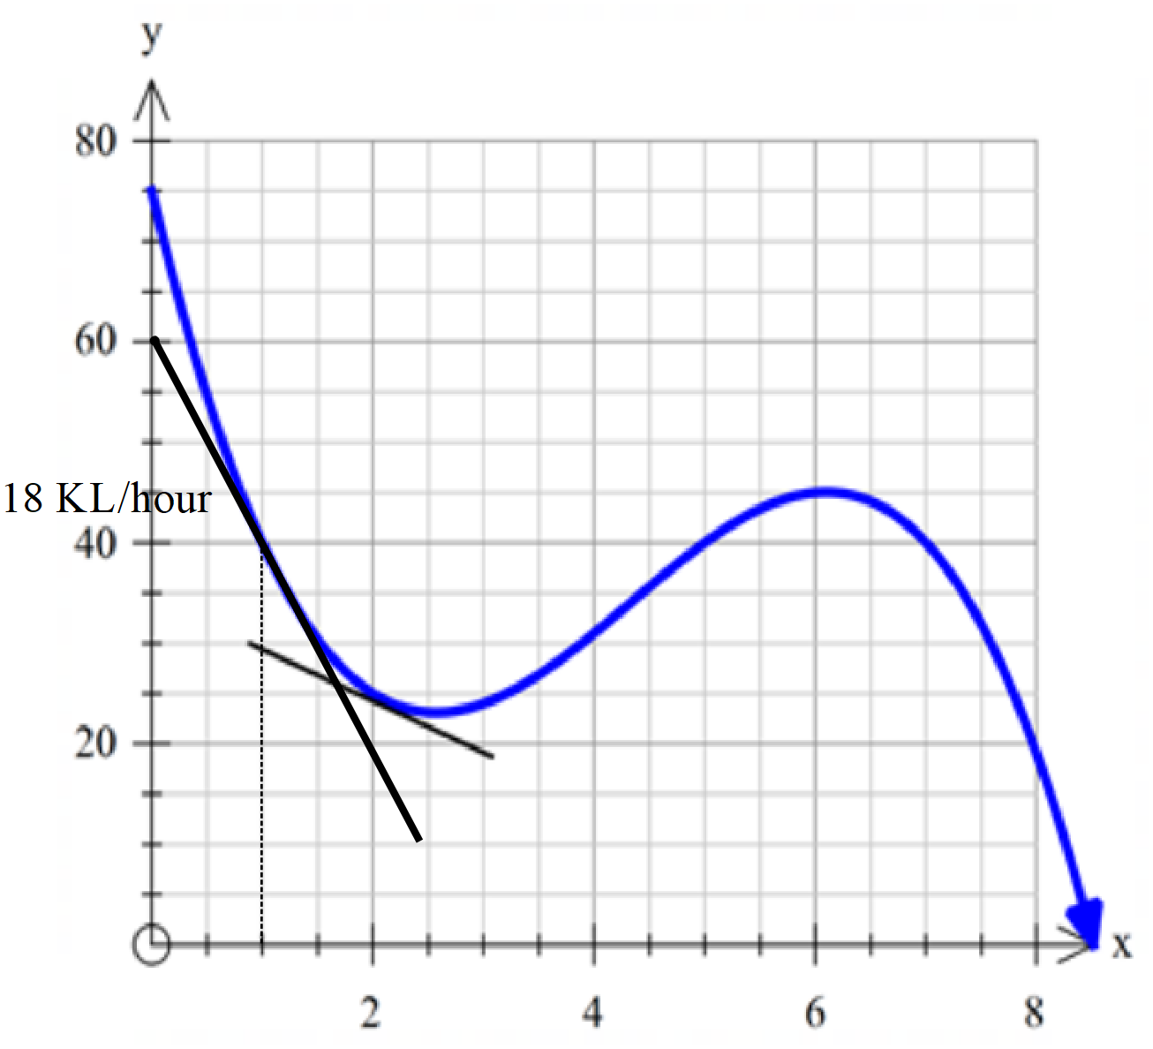

Use the graph to estimate:

1. the volume of water in the tank after seven and a half hours. (1 mark)

|  |
| --- |
| **Solution** |
| Approx 32 kL () |
| ✔ correct answer |

1. the average rate of change of volume from the fourth to seventh hour. (2 marks)

|  |
| --- |
| **Solution** |
| V4≈32kL () V7≈40kL () ∴Ave Change = kL per hour |
| ✔ Volumes  ✔ Calculates Ave |

1. the earliest time, to the nearest quarter of an hour, at which the instantaneous rate of decrease of volume of water is 5 litres per second. (3 marks)

|  |
| --- |
| **Solution** |
| Approx at |
| ✔ Gradient -18 KL/hour or approx.-20 (-1 if -5 used on graph)  ✔ shows tangent line on graph  ✔ States time |

**Question 10 (6 marks)**

A weather balloon is released and allowed to float vertically upwards from the ground into the atmosphere. The height increase after 1 minute is 50 metres. Thereafter, its height increase during each minute is 95% of the height of the height increase during the previous minute.

1. Find the height increase during the 9th minute. (1 mark)

|  |
| --- |
| **Solution** |
| ✔ |

1. What is the height of the balloon after 9 minutes? (2 marks)

|  |
| --- |
| **Solution** |
| ✔ |

1. After how many minutes does the height of the balloon first exceed 650m? (1 mark)

|  |
| --- |
| **Solution** |
| ✔ After |

1. Does the balloon ever reach an altitude of 1 km? Justify your answer. (2 marks)

|  |
| --- |
| **Solution** |
| No as Sum to infinity = 1 km. Balloon approaches an altitude of 1 km but never reaches 1 km. |
| ✔ No  ✔Justification |

**Question 11 (8 marks)**

1. Sketch the function on the axes below. (2 marks)

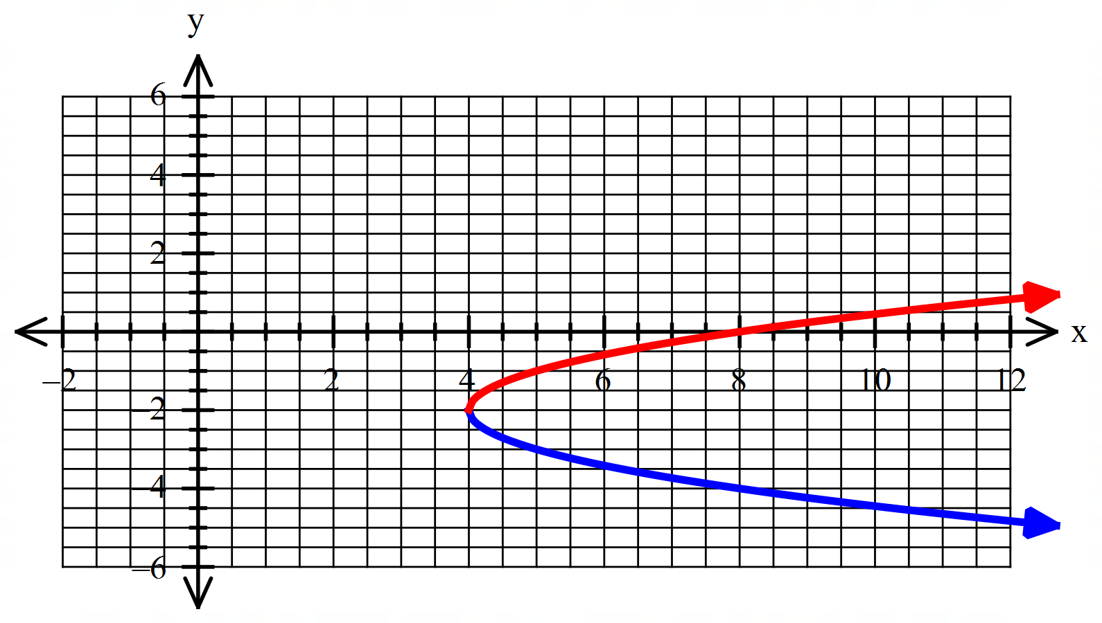

1. Transform the function by a reflection in the -axis and a vertical translation of 4 units in the negative direction of the -axis and sketch the new function, , on the axes above. (2 marks)

|  |
| --- |
| **Solution** |
| See **red** function |
| ✔ vertex  ✔ shape |

1. Write an equation which represents the combined relationship of the two graphs drawn. (2 marks)

|  |
| --- |
| **Solution** |
|  |
| ✔  ✔ |

1. Does your equation in part (c) represent a function? Explain your answer. (2 marks)

|  |
| --- |
| **Solution** |
| No, the equation fails the vertical line test as it has multiple values of *y* for the same value of *.* |
| ✔ No  ✔Justification |

Question 12 (11 marks)

The production of recycled paper in the country of Greentopia has been increasing for some years. Since production began the amount produced, in thousands of tonnes, over the first five years was:

|  |  |  |  |  |  |  |
| --- | --- | --- | --- | --- | --- | --- |
| **Year**  ***n*** | 1998 | 1999 | 2000 | 2001 | 2002 | 2003 |
| **Tonnes**  ***Tn*** | 400 | 435 | 470 | 505 | 540 |  |

1. State why the sequence of production of recycled paper could be described as ‘*Arithmetic’*. (1 mark)

|  |
| --- |
| **Solution** |
| Each term can be found by **adding** thousand to the previous term. |
| ✔ identifies a common difference |

1. State the recursive rule for the production of recycled paper.(2 marks)

|  |
| --- |
| **Solution** |
|  |
| ✔ correctly states recursive rule  ✔ correctly states first term |

1. Find the value of *.* (1 mark)

|  |
| --- |
| **Solution** |
|  |
| ✔ correctly determines |

1. Determine in which year the production would have been 820 000 tonnes. (2 marks)

|  |
| --- |
| **Solution** |
| The year is |
| ✔ determines  ✔ states year as (allow ft) |

1. Determine the total mass of recycled paper produced between 1998 and 2008, inclusive. *Assume the increase in production continues to increase in the same way for at least that long.* (3 marks)

|  |
| --- |
| **Solution** |
| total mass is 6 325 000 tonnes |
| ✔ identifies  ✔  ✔ correct units |

1. During which year did the total amount produced since 1998 first exceed fourteen million tonnes? (2 marks)

|  |
| --- |
| **Solution** |
| i.e. in the 20th year  during 2017 |
| ✔ determines  ✔ states year as (allow ft) |

**Question 13 (5 marks)**

A shark is sighted at P, 800m from the beach on a bearing of 023from B. A few minutes later it is sighted at Q, 1100m from B on a bearing of 065 heading back towards P.



1. What is the size of angle PBQ? (1 mark)

|  |
| --- |
| **Solution** |
| = 420 |
| ✔ correct |

1. How far is it from P to Q? (2 marks)

|  |
| --- |
| **Solution** |
| = 736km |
| ✔ correctly states cosine rule  ✔ answer correct  Accept 800m from point B or from the perpendicular. Accept both interpretations. |

A patrol boat is launched to search the triangular region PBQ.

1. What is the area of the search region? (2 marks)

|  |
| --- |
| **Solution** |
| = 294417 sq km |
| ✔ correctly states area rule  ✔ answer correct |

Question 14 (6 marks)

The town council has been trying to control the wild rabbit population after it blew out of control before 2010. Their observations of the population since control measures were put in place in 2010 have been recorded below.

|  |  |  |  |
| --- | --- | --- | --- |
| **Year** | 2010 | 2012 | 2014 |
| **Population** | 60 000 | 48 600 | 39 366 |

1. Determine an equation in the form that models the population of the species for years after 2010. (3 marks)

|  |
| --- |
| **Solution** |
|  |
| ✔ determining ratio  ✔determining  ✔ determining equation |

1. By what percentage is the population decreasing each year? (1 mark)

|  |
| --- |
| **Solution** |
|  |
| ✔ correct answer (allow ft) |

1. What will be the population in 2020? Give your answer in scientific notation to 2 decimal places. (2 marks)

|  |
| --- |
| **Solution** |
|  |
| ✔ correct answer (allow ft)  ✔ written in scientific notation to 2 decimal places |

Question 15 (8 marks)

Rectangle ABCD is enclosed within another rectangle PQRS so that the sides AB and PQ are parallel and 2cm apart. The vertical distance between sides CD and RS is 3cm and the horizontal distances between sides BC and QR and sides AD and PS are both 4cm.



Let PQ and PS. The perimeter of PQRS is 120 cm.

1. Explain why . (1 mark)

|  |
| --- |
| **Solution** |
| P(Rect)=2L + 2W  ∴ 120 = 2x + 2y |
| ✔ Explains |

1. Show that the area of rectangle ABCD. (3 marks)

|  |
| --- |
| **Solution** |
| From a)  →  ∴ Area = |
| ✔ Length and width in terms of x and y  ✔substitutes for y  ✔ show expansion |

1. Use differentiation to find the maximum possible area of ABCD. (4 marks)

|  |
| --- |
| 1. **Solution** |
| Max/Min Hence when  = 552.25 sq cm  (need to show it is the max using either the sign test or second derivative) |
| ✔ Finds derivative  ✔ Puts derivative =0 and solves for x  ✔ Finds area  ✔ Shows that this is max – sign test or second derivative |

**Question 16 (8 marks)**

A curve with the equation passes through the point The gradient function of this curve is given by

1. Find an equation of the curve, giving your answer as a polynomial in simplest form.

(3 marks)

|  |
| --- |
| **Solution** |
| ✔    ✔  ✔ |
| ✔ anti-derivative  ✔substituting coordinate to find  ✔ finding |

1. Show clearly that the function can be expressed in the form . (2 marks)

|  |
| --- |
| **Solution** |
| is a factor ✔    ✔ |
| ✔ showing that is a factor  ✔ finding the second factor |

1. 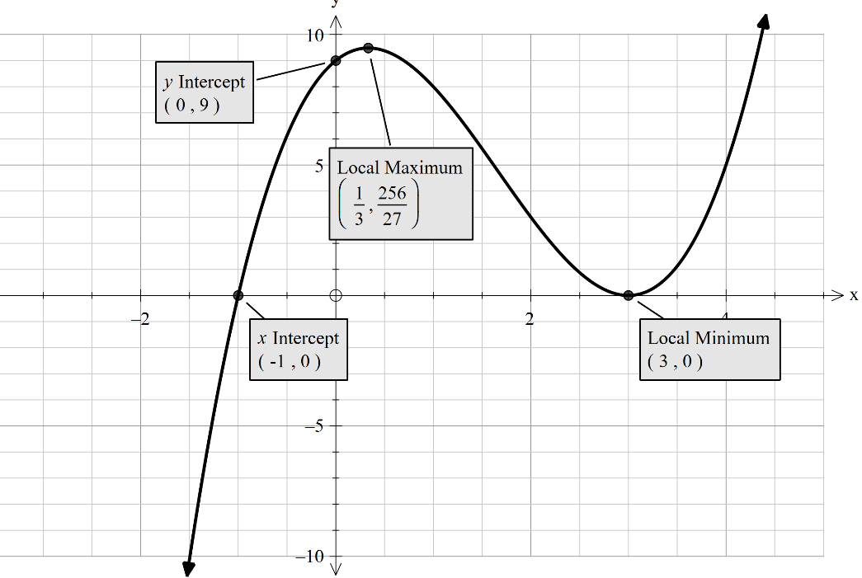Sketch the graph of showing **all** important features of the graph. (3 marks)

✔ shape

✔ maximum

✔ intercepts

Question 17 (8 marks)

1. A bag contains five similar sized cards, each with a different digit on it. The digits are 2, 3, 4, 5 and 6. Three cards are removed at random from the bag and placed next to each other to form a number.

(i) How many different numbers can be made? (1 mark)

|  |
| --- |
| **Solution** |
|  |
| ✔ correct number |

(ii) What is the probability that the number does not contain the digit 4? (1 mark)

|  |
| --- |
| **Solution** |
|  |
| ✔ correct probability |

(iii) What is the probability that the number is a multiple of 5, given that the first digit chosen is an even number? (2 marks)

|  |
| --- |
| **Solution** |
|  |
| ✔ correct numerator  ✔ correct denominator |

1. S and are independent events such that and . (4 marks)

Determine .

|  |
| --- |
| **Solution** |
| and  The events and are independent. |
| ✔ uses independence law  ✔ Uses addition law  ✔ Substitutes for values except *P*(S)  ✔ Evaluates *P*(*T*) |

**Question 18 (9 marks)**

1. Given the unit circle below determine the value (in terms of a and or b) of:
2. 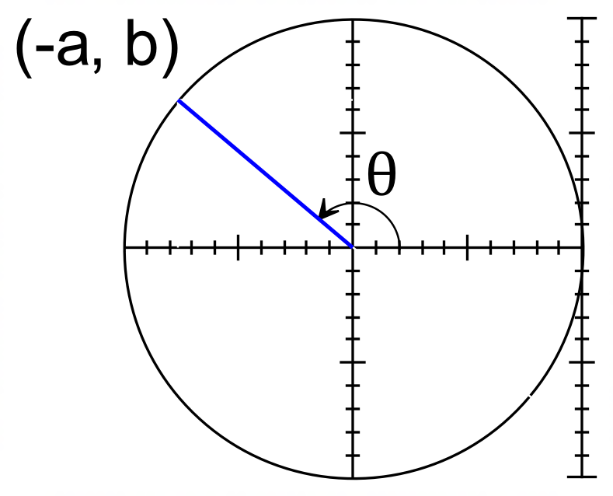 (1 mark)
3. (1 mark)

1. (1 mark)
2. (1 mark)

|  |
| --- |
| **Solution** |
| 1. ii) iii) iv) |
| ✔✔✔✔ for each part |

1. Given that the curve below is represented by , determine possible constants for and . (2 marks)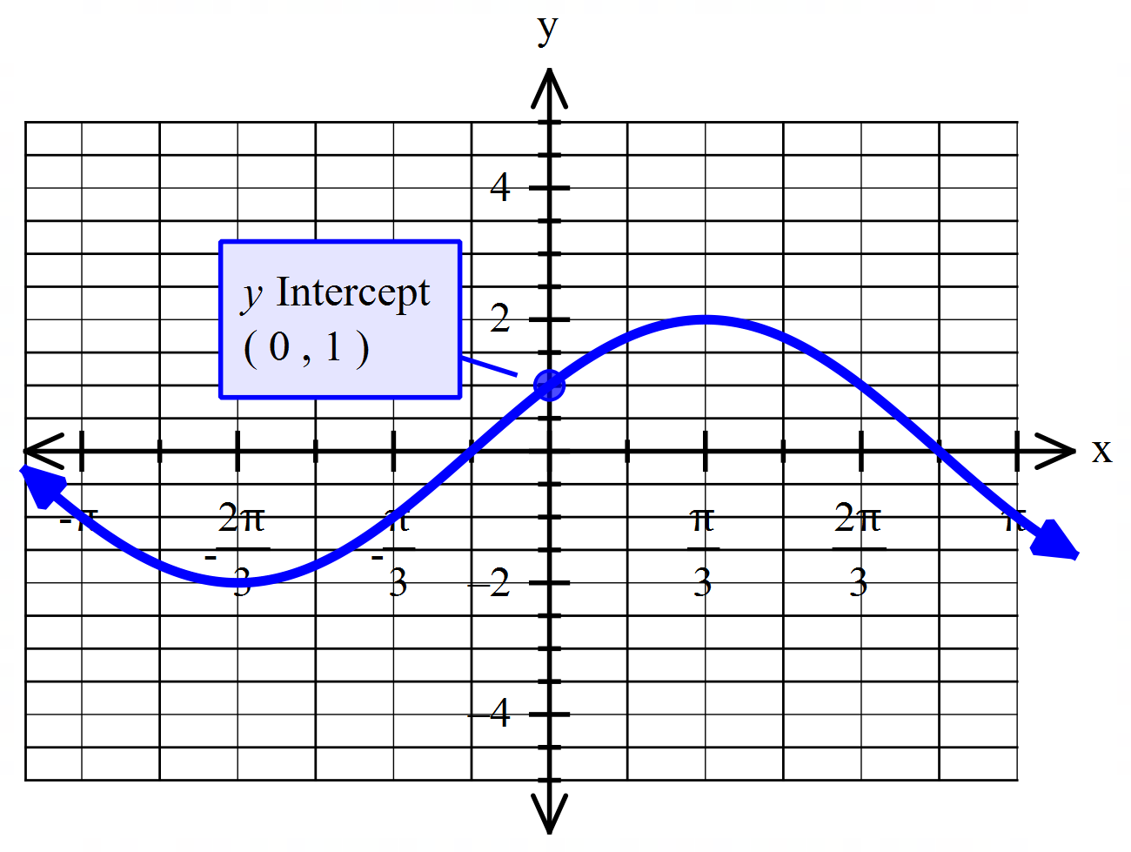

|  |
| --- |
| **Solution** |
|  |
| ✔ correct value for  ✔ correct value for |

1. A cosine curve has a period of with a mean line of and a phase shift of . Given that has a minimum value of 1, find a possible equation of this curve. (3 marks)

|  |
| --- |
| **Solution** |
| or |
| ✔ correct value for  ✔ correct value for  ✔ correct value for |

**Question 19 (10 marks)**

At the Crown Towers, checked-in guests may choose to have breakfast and dinner at the hotel. Walk-in guests can book to have dinner. On a certain day, a person who resides at Crown Towers or had dinner at the hotel is selected at random. The probability that this person had breakfast in the hotel is 0.5, while the probability that they had breakfast and dinner is 0.2. The probability that this person is a checked-in guest and had dinner at one of the restaurants inside the hotel is 0.32. It is thought that a person having breakfast or dinner are independent events.

Let the following variables represent the probability for the following events:

B – had breakfast at the hotel,

C – checked in guests,

D – had dinner at the hotel.

1. What is the probability that a person selected had dinner at the hotel? (2 marks)

|  |
| --- |
| **Solution** |
|  |
| ✔ uses independence law  ✔ answer |

1. Complete the Venn Diagram to illustrate the information above. (4 marks)

|  |
| --- |
| **Solution** |
|  |
| ✔✔✔✔ for each correct answer |

1. Determine the probability that this person:
2. stayed at the hotel and had breakfast elsewhere. (2 marks)

|  |
| --- |
| **Solution** |
|  |
| ✔ 0.3  ✔ 0.12 (-1 mark for additional numbers) |

1. is checked in at the hotel and had breakfast elsewhere, given that he/she had dinner in the hotel. (2 marks)

|  |
| --- |
| **Solution** |
|  |
| ✔ correct numerator  ✔ correct denominator |

**Question 20 (5 marks)**

The displacement, x, of a particle is given by:

1. If the particle changes direction when t=2, calculate the value of a. (3 marks)

|  |
| --- |
| **Solution** |
| since particle is changing direction |
| ✔ differentiating  ✔ equating to  ✔ calculating |

1. Determine whether the particle reached a local maximum or minimum displacement at t=2, show all working. (2 marks)

|  |
| --- |
| **Solution** |
| the particle reaches a local maximum at |
| ✔ double differentiation / sign test  ✔ local maximum at |

**End of questions**